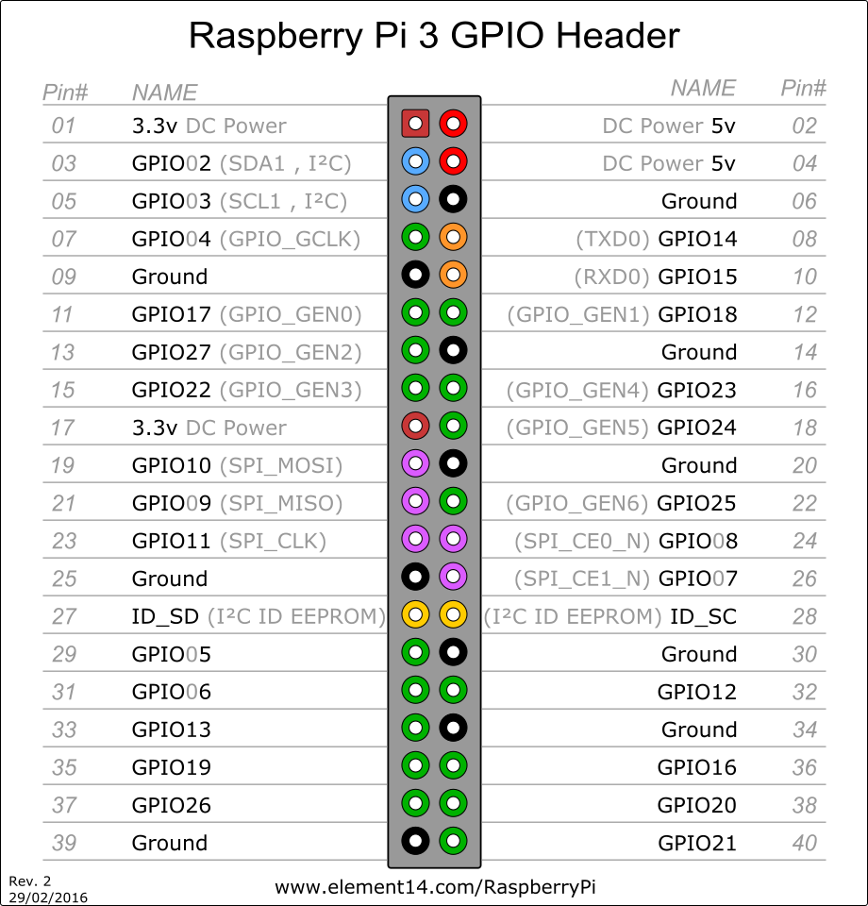Pin functions:

|  |  |  |
| --- | --- | --- |
| Function | Board Pin Number | Input/output/5V/3.3V/Ground |
| Buzzer | 7 | Output |
| PIR Sense | 13 | Input |
| Reed Switch Sense | 15 | Input |
| Orange LED | 16 | Output |
| Red LED | 18 | Output |
| Ground LED | 20 | Ground |
| Green LED | 22 | Output |
| Siren | 29 | Output |
| Keypad Row (1) | 31 | Output |
| Keypad Row (2) | 33 | Output |
| Keypad Row (3) | 35 | Output |
| Keypad Row (4) | 37 | Output |
| Keypad Colum (1) | 36 | Output |
| Keypad Colum (2) | 38 | Output |
| Keypad Colum (3) | 40 | Output |